*Ciência Animal* 23(1): 37-43,2013

## TOXOPLASMOSIS: MORPHOLOGICAL EVALUATION OF SPINAL CORD NEUROGLIA FROM NONSYMPTOMATIC SEROPOSITIVE DOGS

(Toxoplasmose: avaliação morfológica da neuróglia da medula espinhal de cães soropositivos assintomáticos)

Alessandra Cristina Francischini de Carvalho 1 Maiia Rita Pacheco 1

Silvana Maitinez Baraldi­

, ,

Artoni 1 Annita Morais Girai·di2*

,

1 Departamento de Morfologia e Fisiologia Animal, Faculdad e de Ciências Agrárias e Veterinárias - UNESP Campus de Jaboticabal.

2 Departamento de Clinica e Cimrgia Veterinária , Faculdade de Ciências Agrárias e Veterinárias - UNESP Campus de

Jaboticabal. Autor para correspond ência.

## ABSTRACT

This paper aims to analyze the morphology of the cells that compose the neuroglia of cervical, thoracic ai1d lumbar spinal cord of non symptomatic dogs seropositive for *Toxoplasma gondii.* Twenty adult, mongrel dogs were used ; ten healthy dogs, with negative serology for Toxoplasma, used as the cont:rol group (group 1) ai1d ten non symptomatic dogs but seropositive for *Toxoplasma gond ii* (group 2). After microtomy , the histological sections were stained with hematoxylin-eosin (HE), Masson's trichrome (MT), silver impregnation and by peroxidase-antiperoxidase (PAP) method. Tirn slides were analyzed under optical microscopy to ve1ify the morphology of these cells. The morphological chai·acteristics between the two groups were similar and iI1 accordance with literature. Thus, it was concluded that toxoplasmosis does not cause changes, visible by optical microscopy , in the neuroglia of the spinal cord of non symptomatic seropositive dogs.

Key-words: caiüne, central nervous system, histology, *Toxoplasma gondii*

## RESUMO

Este trabalho objetivou analisar a morfologia das células que compõem a neuróglia das regiões cervical, torácica e lombai· da medula espinhal de cães assintomáticos soropositivos para toxoplasmose. Utilizou-se 20 cães sem raça definida, adultos, dos quais dez apresentai·am sorologia negativa para toxoplasmose, utilizados como controle (grupo 1) e dez foram assintomáticos, mas soropositivos para toxoplasmose (grupo 2). Após microtomia semi-seriada, os c01tes histológicos foram corados pelas técnicas da hematoxilina-eosina (HE), do u·icrômico de Masson (TM), da impregnação pela prata e pelo método ilnunoenzilnático indii·eto da Peroxidase Antiperoxidase (PAP). As lâminas foraiu analisadas à luz da microscopia óptica pai·a verificar a morfologia destas células. As caractelisticas mo1fológicas entr·e os dois grupos foram semelhantes e em conformidade com a literatura clássica. Assin1, concluiu-se que a toxoplasmose não causa alteração mo1fológica , visível à microscopia óptica, na neuróglia da medula espinhal de cães assintomáticos soropositivos . Palavras-chave : canino, sistema nervoso cenu·al, *histologia,Toxoplasma gondii*

*Endereço para correpond ência:

E-mail: annitamgirardi @gmail.com

## INTRODUCTION

Neuroglia comprises astrocytes , oligodendrocytes , microglial and ependymal cells. Astrocyteshave shape similar to a star, with two main morphologic types: protoplasmic , found in gray matter, with thicker, shorter and profusely branched extensions; and fibrous, in white matter, withlong, thin and less branched extensions.Ependymal cells are cuboid or p1ismatic,present in natural cavities of CNS, haveepithelial aITangement,microvilli usually with cilia in their lurninal wall andone extension or basal process that penetrates the nervous tissue around cavities.Oligodendrocytes , found in white and gray matter, are smaller than astrocytes, have few short extensions, and producethe myelin sheath of axons.Microglial cells are small and elongated, having few sh01t extensions that come out from their edges with dense, elongated and iITegular nucleus,covered by thi11 spikes, found in white and gray matter and have phagocytic functions (Hii·ano, 1985; Chrisman, 1997; George & Castro, 1998; Machado, 2002 ; Ross & Pawlina, 201 l;Junqueii·a&Cameii·o, 2013).

Encephalitis in dogs are often caused by *Toxoplasma gondii (T. gondii )* and *Neospora caninum* (Paixão & Santos, 2004). Dogs are considered veiy receptive animals for toxoplasmosis, probably due to their camivorous eating habit, what facilitates the ingestion of tissues contaminated by cysts and their contact with sporulated oocysts in contaminated soil (Gennano, 1985).111e infection has been noticed in cats and dogs in many countries.

Severe and fatal cases have been repo1ted although clinica! manifestations are uncommon due to the efficiency of *T. gondii* parasite (Hass et al., 1989; Lindsay, 1990; Guilnarães et al., 1992; Paixão & Santos,

2004).Although many anilnals are serologically positive for toxoplasmosis , few develop clinica! signs of disease (Lappin, 2004; Dubey & Lappin, 2012).It is presumed that disease manifestationoccurs by local or systemic ilnmune deficit of host organism, so that ilnmunosuppressed patients may have p1imary or recurrent infection (Swinger et al., 2009). The most conunon histopathologic changes in CNS toxoplasmosis are non suppurative meningo encephalomyelitis with vasculitis, necrosis, malacia and gliosis with possible involvement of peripheral nerves (Dubey & Lappin, 2012 ;Giraldi et al., 2002).

Histopathological evaluation of brains and spinal cords of *T. gondii-in fected* mice revealed comparable pathological processes, withhigh counts of i11filtrated inflammatory cells, presence of cysts mostly in the grey matter , neuronal degeneration and hemonhage. Inflammatory foci and *T. gondii* cysts were widely recognized in the brain and the spinal cord without any preference for a specific area. Despite the presence of recruited i11flanunatory cells and generalized activation of resident cells, no obvious changes in the myelin stailüng intensivity or axonal density could be observed i11the spinal cords. Resident microglia and astrocytes displayed a strong activation in the grey and white matter in the spinal cord, with control animals showing only very small foci of astrocytes whereas in infected animals, the background is filled with processes of activated astrocytes (Mõhle et al., 2014). Carvalho et al. (2015) reported similar morphological characteristics in spi11al neurons of dogs negative for toxoplasmosis and seropositive non symptomatic dogs, but morphometiic results showed changes in neurons size, sti·ucture and loss of star shape in seropositi ve animals.

Consideiing the histopathological changes observed in the CNS with clinica!

toxoplasmosis , and the absence of researches in dogs infected but without clinicai signs, this studyaimed to analyze the occurrence ofhistological alterations 111 neuroglia structures of the spinal cord of non symptomatic dogs with high serological reactivity to toxoplasmosis .

**MATERIAL AND METHODS**

For the proposed objectives were used twenty indefmite-breed adult dogs, weighing from 7 to 15 kg, from the Zoonosis Control Center of Araraquara city, state of São Paulo, Brazil. The serology for *T gondii* was performed by Enzyme-Linked Immunosorbent Assay (ELISA), with technique described by Domingues et al. (1998), 111 Department of Veterinary Pathology of School of Agrarian and Veteiinary Sciences, São Paulo State University, Jaboticabal, Brazil. The reactivity of sera was analyzed in tenns of ELISA leveis (from O to 9) and the animais used in this study were those that presented reactivity 8 or 9.Ten dogs, with negative serology for *T gondii ,* were used as control group (group 1) and ten non symptomatic dogs, with leveis of reactivity for *T gondii* over 8, detected by Enzyme-Linked Inununosorbent Assay (ELISA), used as reagent group (group 2).

After the formation of groups 1 and 2, fragments of spinal cord corresponding to cervical, thoracic and lumbar spinal cord were collected at post-m01tem, being removed from the medullary canal using a blunt­ pointed forceps, and fixed in Bouin's solution for 24 hours and processed routinely for paraff111 embedding.

After microtomy at interval of 1OOµm, histological sections of 5µm thickness were stained with hematoxylin-eosin (HE) and Masson's trichrome (MT) techniques. Slices of 15µm thickness were stained by silver

impregnation. All three techniq ues were

perfo1med according to Tolosa et al. (2003). Slices of 5µm thickness were stained by the immunohistochemistry PAP (peroxidase antiperoxidase) technique using the primary antibody anti-glial fib1illary acidic protein (anti-GFAP, according to Lemos & Alessi (1999), to identify astrocytes.

The glass slides were examined by optical microscopy to veiify the morphology of stmctures and were photographed using a photo microscope model Olympus BX50 (Olympus Ame1ica Inc., New York, USA).

**RESULTS AND DISCUSSION**

The morphology of astrocytes, revealed by enzyme immunoassay of PAP, was characte1istic and easily viewed because of the brown color of their cytoplasm. The astrocytes located in the white matter, known as fibrous, had long and less branched extensions (Fig. 1), and the protoplasmic astrocytes, located in the gray matter, presented sh01t and profuse extensions (Fig. 2).The observations on the astrocytes recall the repo1ts of Hirano (1985), Machado (2002), Carvalho et al. (2005) and Junqueira

& Carneiro (2013), when they recognize two major morphologic types of this cell: protoplasmic and fibrous. The distinction of two types of cells based on their location and number of cytoplasmatic extensions agrees with Machado (2002), Ross & Pawlina (2011), and Junqueira & Carneiro (2013). TI1e GFAP, subunit of the inte1mediary filaments of the cellular cytoskeleton, exists in the cytoplasm of astrocytes, so **immunohistoche1nistry using primary** antibody anti-GFAP is generally chosen to identify astrocytes in the CNS (Lemos & Alessi, 1999; Ross & Pawlina, 2011).

The ependymal cells from studied reg10ns of the spinal cord of dogs presentedsin1ple epithelial arrangement , with

cylindlical cells with cilia, in both groups

(Fig. 3), matching what was w1itten by George & Castro (1998), Machado (2002) and Junqueira & Carneiro (2013).

The histological sections, impregnated with silver, presented the microglia with elongated cellular bod y, being invisible the nucleus and the cytoplasmic processes , characteiistics observed in both groups (Fig. 4), what facilitated the differentiation of other cells of neuroglia, which had spherical nucleus. The oligodendroglia showed, by the method of silver impregnation, round cellular body (Fig. 4), but nucleus and cytoplasmatic extensions were invisible. These observations were similar in the mentioned segments of the spinal cord of dogs in both groups.The evidences on oligodendroglia and microglia resemble the illustrations on Di Piore et al. (1982) and the repo1ts of Carvalho et al. (2005) when they mention, using the silver impregnation method, that the cellular body of oligodendroglia is round , basic characteristic, to differentiate from microglia , whose cellular body is elongated and shmt.

The cells of neuroglia were present, their morphology remained unchanged and with similar aspect in both groups, in the three spinal cord segments.Thus, it can be considered that highly reactive animals to toxoplasmosis by ELISA test, but asymptomatic , showed no morphological differences m neuroglia by optical microscopy compared tononreactive animals.

There is a need for differential diagnosis of toxoplasmosis in dogs with nervous symptoms in relation to other diseases that also affect this system (Moretti et al., 2002). Plugge et al. (2011), after a study in which 21.08% of dogs with nervous signs were seropositi ve for *T gondii* by means of the indirect fluorescent antibody test (IFAT), recommended serological tests in diagnosing neurological diseases in dogs. However, this present study indicate that an

animal positive to toxoplasmosis does not

necessarily exhibit neurological signs due to ne1vous lesions by this disease.

The morphological characteristics desc1ibed disagree with Mõhle et al. (2014), which observed, byhistopathological exanlination of different segments of spinal cordof *T gondii-in fected* mice, high counts of inflaimnatory cells, cysts mostly in the grey matter, neuronal degeneration, hemolThage, resident microglia and astrocytes displaying strong activation in grey and white matter, while control animals showed ve1y small foci of astrocytes. These authors suggest rather altered function of the spinal cord neurons and less or no structural alterations (Mõhle et al., 2014), situation that cannot be excluded in relation to neuroglia, but cai1 only be evaluated using other scientific methods .

## CONCLUSIONS

lt was concluded that toxoplasmosis does not cause visible chai1gesby optical microscopy in the neuroglia of the spinal cord of non symptomatic seropositive dogs. This obse1vation is impo1tant for differential diagnosis of neurological diseases in dogs.

## REFERENCES

CARVALHO, A. C. F.; PACHECO, M. R.; BARALDI-ARTONI , S. M.; MATEUS, O.

Morfologia de células neurológicas e imunológicas da medula espinhal de cães *(Canis familiaris ,* Linnaeus, 1758). **Acta Scientiarum Animal Sciences,** v.27, n.3 , p.383-390 , 2005.

CARVALHO, A. C. F.; PACHECO, M. R.; BARALDI-ARTONI , S. M.; GIRARDI, A.

M. Toxoplasmosis: morphological and morphometlic evaluation of spinal cord neurons from non symptomatic seropositive dogs. **Ciência Animal Brasileira ,** v.16, n.2 ,

p.225-234 , 2015.

# CHRISMAN, C.L. Neurologia dos pequenos animais . São Paulo: Roca, 1997.432p.

DI PIORE, M.S. H.; MANCINI, R. E.; DE

ROBERTIS, E.D.P. Novo atlas de histologia .

5 ed. Rio de Janeiro: Guanabara Koogan, 1982. 335p.

DOMINGUES, L. M.; MACHADO , R. Z.; TINUCCI COSTA, M.; CARVALHO, C. S.; COSTA, A. J.; MALHEIROS , E. B. Canine

toxoplasmosis: a comparative evaluation of the detection of *anti-toxoplasma gondii* antibodies by the indirect immunoenzymatic assay (ELISA) and the indirect immunofluorescence reaction (IFF). Revista Brasileira de Parasitologia Veteriná ria, v.7, n.2, p.79-85 , 1998.

DUBEY, J. P.; LAPPIN, M. R.

Toxoplasmosis and neosporosis. ln: GREENE, C. E. Infectious diseases of the dog and cat. 4 ed. Saint Louis: Elsevier, 202. p.806-8 27.

GERMANO, P.M.L. Estudo sorológico da toxoplasmose caruna, pela prova de imunofluorêscencia indireta, na cidade de Campinas em 1981, Revista da Faculdade de Medicina Veterinária e Zootecnia , v.22, p.53-58, 1985.

GEORGE, L.L.; CASTRO, R.R.L. Histologia

Comparada, 2 ed. São Paulo: Roca, 1998. 286p.

GIRALDI, J. H.; BRACARENSE, A. P. F. R.; VIDOTTO, O.; TIJDURY, E. A.; NAVARRO, I. T.; BATISTA, T. N. Serology

and histopathology of *Toxoplasma gondii and Neospora caninum* in dogs with neurologic disorders. Semina : Ciências AgráJ.ias, v.23 , n.l, p.9-14, 2002.

# GUIMARÃES, A.M.; RIBEIRO, M.F.B.; LIMA, J.D.; CURY, M.C.; SPIEWAK, G.

Freqüência de anticorpos *anti-Toxoplasma gondii* em cães de Belo Horizonte, Minas Gerais. Arq uivo Brasileiro de Medicina Vete1inária e Zootecnia , v.44, n.l , p.67-68 ,

1992.

HASS, J. A.; SHELL, L.; SAUNDERS, G.

Neurological manifestations of toxoplasmosis : a literature review and case summary. Journal of the American Animal Hospital Associa tion, v .25, p.253-260, 1989. HIRANO, A. Neurons , astrocytes and ependyma. ln: DAVIS, R.C.; ROBERTSON,

D.M. Textbook of neuropa thology .Baltimore: Willians & Willians, 1985. p.1-91.

JUNQUEIRA , J.; CARNEIRO, F. Tecido

neivoso. In:Histologia bá sica: texto &atlas. 12 ed. Rio de Janeiro: Guanabara Koogan, 2013. p.149-175 .

LAPPIN, M. R. Infecções protozoáJ.ias e mistas. ln: ETTINGER , S. J.; FELDMAN, E.

C. Tratado de medicina interna veterinária: doenças do cão e do gato. 5ed. Rio de Janeiro: Guanabara Koogan, 2004. p.433-435.

LEMOS, K.R.; ALESSI, A. C.Astrócitos

imun01Teativos à proteína glial fib1ilar àcida (GFAP) em sistema nervoso central de equmos nonnais e de equmos com leucoencefalomalàcia .Pesquisa Veterinária Brasileira , v.19 , n.3/4, p.104-108, 1999.

LINDSAY, S. D. Serological prevalence of *Neospora caninurn* and *Toxoplasrna gondii* in dogsfrom Kansas. Journal of Helminthology Society, v.57, n.l, p.86-88, 1990.

# MACHADO , C. R. S. Tecido nervoso. ln: MACHADO , A. Neuroa natomia funcional. 2 ed. São Paulo: Atheneu , 2002. p.7-12.

MÔHLE, L.; PARLOG, A.; PAHNKE, J.;

DUNAY, I. R. Spinal cord pathology in cluonic experimental *Toxoplasma gondii* infection . European Journal of Microbiology and Immunology, v.4, n.l , p.65-75, 2014 .

MORETTI, L. D.; UENO, T. E.; RIBEIRO,

1. G. Toxoplasmose em cães co-infectados com o vírus da cinomose. Semina : Ciências AgráJ.ias, v.23, n. l , p.85-91, 2002.

PAIXÃO, T. A.; SANTOS, R. L. Encefalite por *Neospora caninum* e *Toxoplasma gondii* em cães. **Clínica Veterinária,** v.9, n.48, p.44-52 , 2004.

PLUGGE, N . F.; FERREIRA, F. M.; RICHARTZ, R. R. T. B.; SIQUEIRA , A.;

DITTRICH, R. L. Occurrence of antibodies against *Neospora caninum* and/or *Toxoplasma gondii* in dogs with neurological signs. **Revista de Brasileira de Parasitologia Veterinária ,** v.20, n.3, p.202-206 , 20 11.

ROSS, M. H.; PAWLINA, W. Nervetissue . ln: **Histology:** a text and atlas with correlated cell and molecular biology. 6ed. Baltimore:

Lippincott Williams & Wilkins, 20 11. p.352-

399

SWINGER, R. L.; SCHIMDT, K. A. ;

DUBIELZIG , R. R. Keratoconjunctivitis associated with *Toxoplasma gondii* in a dog. **Vete1inary Ophthalmology ,** v.12, n. l , p.56- 60, 2009.

TOLOSA, E.M.C.; FREITAS NETO, A.G.; BEHMER , O.A.; RODRIGUES, C.J. **Manual**

**de técnicas para histologia normal e patológica .2ed.** São Paulo:Manole, 2003. 33lp.

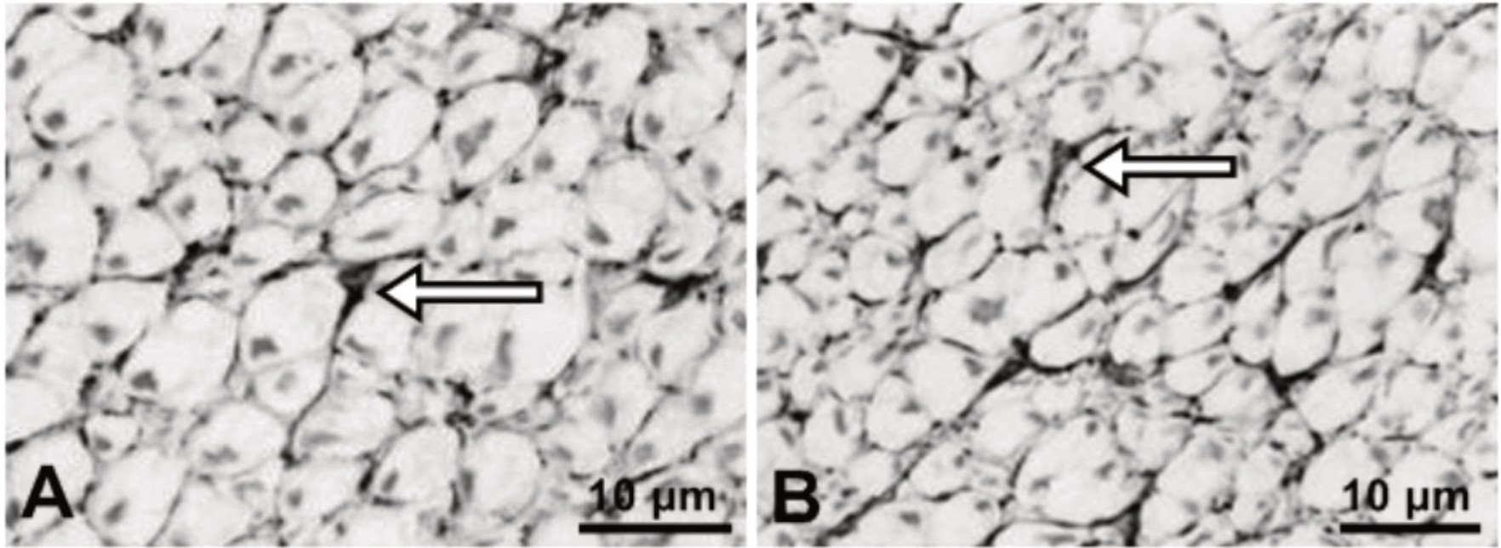

**Figure** l.Photornicrographies of astrocytes from canine spinal cord white matterof control

* 1. and seropositive for toxoplasmosis group (B), showing fibrous astrocytes (airnw).Peroxid ase-antiperoxid ase.

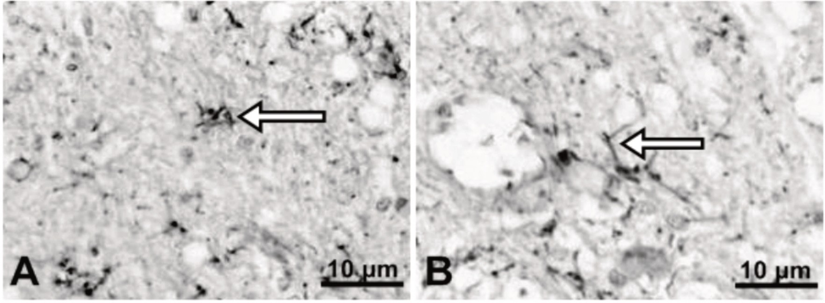

**Figure** 2. Photomicrographies of astrocytes from canine spinal cord gray matter of control

(A) a.nd seropositive for toxoplasmosis group (B), showingprotoplasmic astrocytes (arrow). Peroxidase-antiperoxidase.

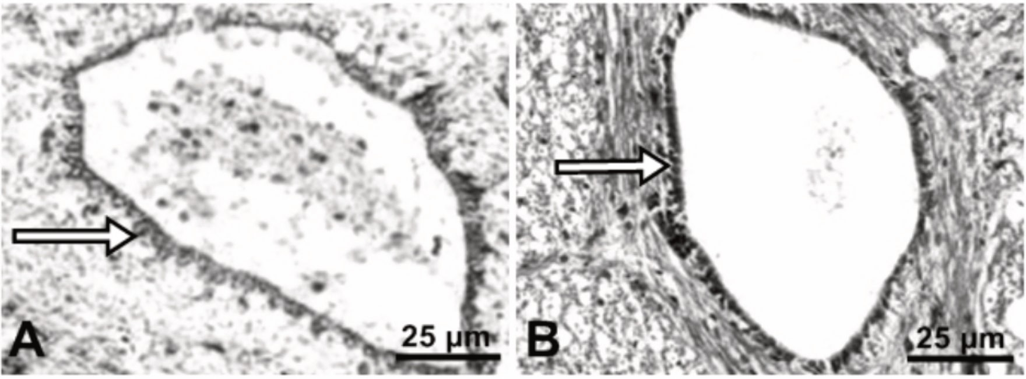

**Figure** 3. Photomicrographies of ependymal cells (anow) from canine spinal cord central canal of control (A) and toxoplasmosis seropositive group (B). Masson's ttichrome.

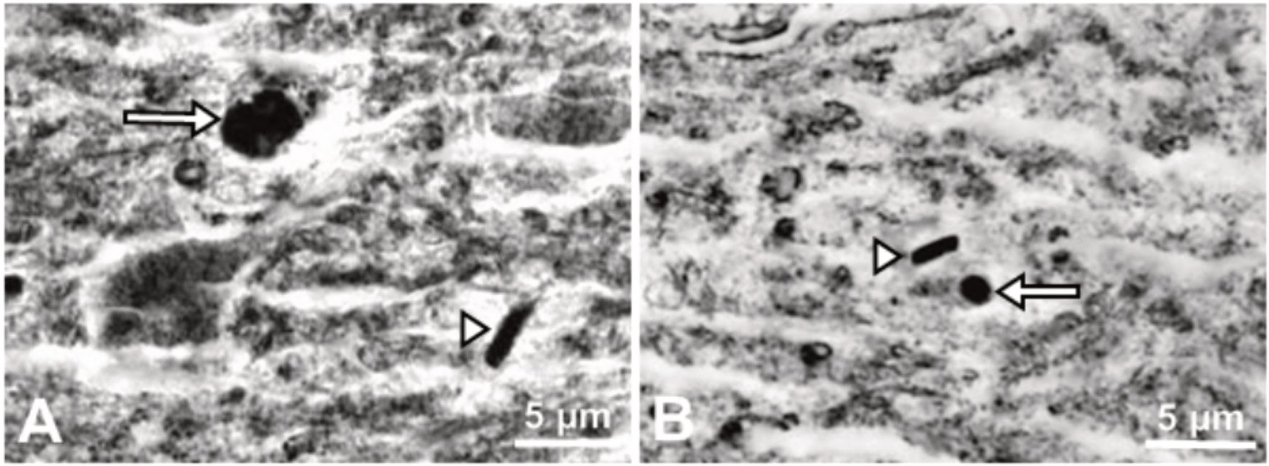

**Figure 4.** Photomicrographies of neuroglia from canine spinal cord gray matter of contt·ol

(A) and toxoplasmosis seropositive group (B), showing oligodentrocyte (ru.row) and microglia (ru.rnw head).Silver impregnation.